1. **SSH file transfer between Raspberry Pi and windows**

We need to transfer files between Windows and Raspberry Pi two different systems. Since this is two different file systems, we need to use the SSH service to transfer files across systems.

1)You need to click this button, as shown in the figure below.

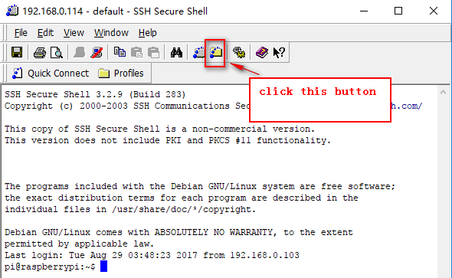

2)You will see an interface,as shown in the figure below.

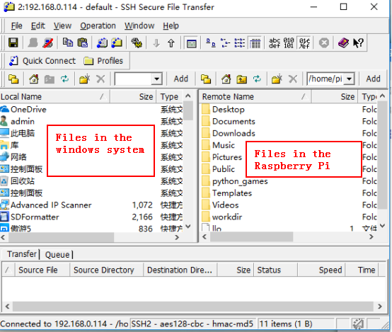

You can transfer files between two systems by dragging the folder directly.

If the system prompts this error: Encountedred 1 error during the transfer.

May be because of two question:

1. Question1:In the Raspberry Pi system, the files without permissions.

Solution: chmod 777 file name

(For example:chmod 777 SmartCar)

1. Question2: In the Windows system, the files without permissions.

Solution: We can move this file to the desktop, and the path and file name of the files with ( ) in the Windows system cannot be transferred.

For example: You need to transfer file_A in the Windows system to file_B in the Raspberry Pi system. If the system prompts this error: Encountedred 1 error during the transfer. You need to input chmod 777 file_B and move file_A without( ) to the desktop.